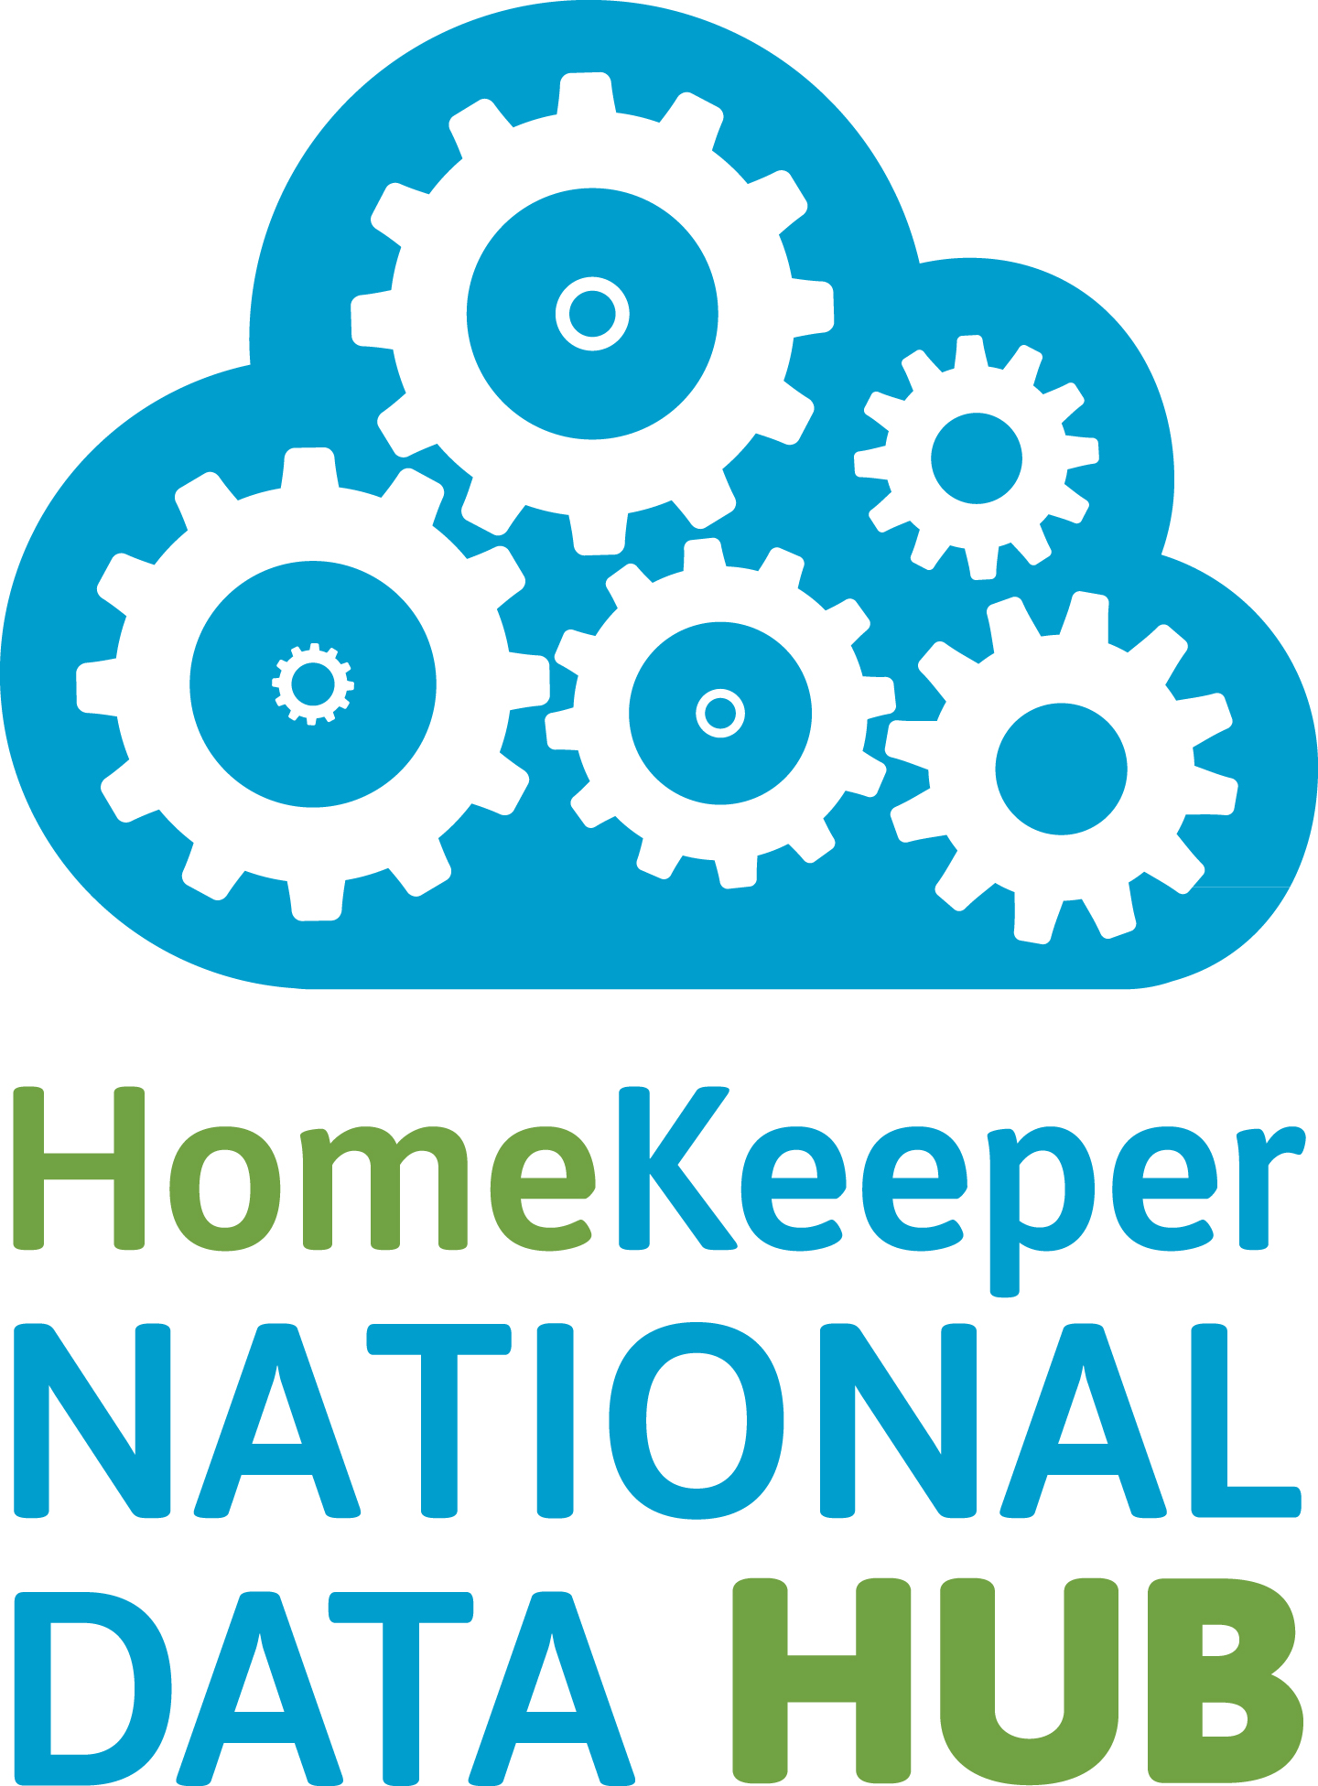
Social Impact Report v2.1 Public
Documentation
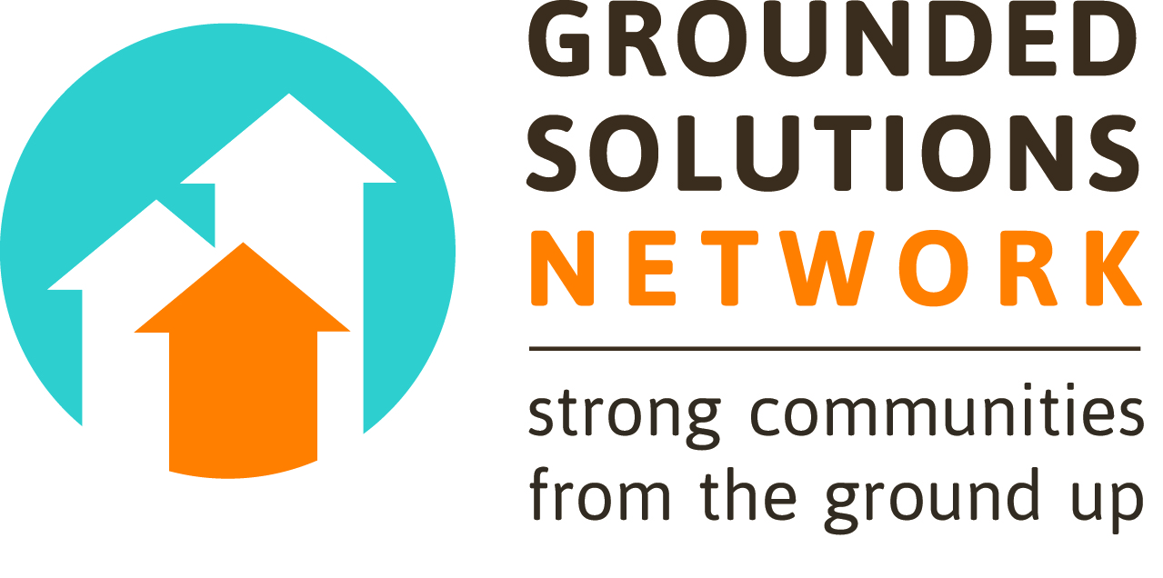

Introduction & Methodology

This is the first ever interactive version of HomeKeeper's Public Social Impact Report. It is designed to help policymakers, researchers, and practitioners assess the performance of the sector, and drill down using the customizable filters in order to answer specific questions about how performance varies across a diversity of market conditions, program types, regions, and demographic profiles.

HomeKeeper is a Salesforce.com based software tool built by Cornerstone Partnership to help long-term affordable homeownership programs manage their portfolios. Over 65 organizations across the US are using HomeKeeper to manage over 100 different programs, including Community Land Trusts, deed restriction programs, shared appreciation loan programs, inclusionary housing programs, and Limited Equity Housing Cooperatives. Most of these organizations agree to migrate select transaction-level data to the HomeKeeper National Data Hub, a central data warehouse owned and operated by Cornerstone Partnership.

Inside the National Data Hub, the data is combined with historical third-party data imported from the US Census and the Federal Reserve Bank (demographics, typical US mortgage interest rates, and S&P500 indexes). It is also transformed in some cases, and analyzed using standardized social impact metrics that were developed with feedback from over 100 experienced practitioners. The results are disseminated back to users in a detailed Social Impact Report for their specific program that allows them to evaluate their performance, compare themselves to their peers, and more effectively tell their stories to funders and policymakers.

This version presents the aggregate data in a publically accessible interactive report, using a business intelligence application called Tableau.

National Summary

This dashboard displays information about the affordable homeownership programs in the dataset. Each organization may have multiple programs, and those decisions are made by program staff.

Program Size
This chart shows the distribution of programs by portfolio size. The counts represent the total number of property records that are complete enough to migrate to our database (must have an address and be associated with a transaction record that has a “certified” close date and at least one funding source). This means that properties that have been acquired but are still in the development pipeline are excluded. Lost units are included.

Region
Northeast = DC, DE, MA, ME, NH, NY, PA, VT
Northwest = MT, OR, WA
Midwest = IL, MN, MO, OH, WI
Southeast = FL, LA, TN
Southwest = AZ, NM, TX
West = CA, CO, NV, UT

Program Type
Each HomeKeeper user selects the one "type" that best describes their overall program model. This information is not collected for each transaction and does not necessarily describe the legal mechanism of affordability preservation used for all of the program's transactions. For example, some organizations choose to separate their deed-restricted units and their ground lease units into two separate programs but others choose to lump them together.

Resale Formula Type
Each HomeKeeper user selects the one "type" that best describes their overall program model. This information is not collected for each transaction and does not necessarily describe the resale formula used for all of a given program's transactions. For example, some programs that change their resale formula may choose to separate those transactions into two different programs while others may choose to lump them together.
Income Cap
Each HomeKeeper user selects the one "income cap" that best describes their overall program eligibility model. This information is not collected for each transaction and does not necessarily describe the eligible income range for all of the program's projects or funders. For example, some organizations that serve multiple income ranges choose to separate those transactions into 2 separate programs, while others choose to lump them together.
Property Portfolio

**Note that the entire portfolio analysis is restricted to those Property records that are complete enough to migrate to our database (must have an address and be associated with a transaction record that has a “certified” close date and at least one funding source). This means that properties that have been acquired but are still in the development pipeline are excluded. Lost units are included.

How much are the homes worth?
This chart uses the maximum market value from any of the Property's associated transaction records, regardless of date. The transaction record field, "Appraised Unrestricted Market Value," is populated automatically by the value recorded on the associated Appraisal record with Type = “Buyer’s Purchase Loan.” Lost units are included in this chart.

How has the portfolio grown?
This chart shows the growth of the collective portfolio over its entire history. Each column gives a cumulative count of properties for a given year. The chart uses the field "Date Placed in Program", which different programs may define differently. If that field is empty, it uses instead the earliest close date of an associated transaction.

How did homes enter the portfolio?
This chart shows the percentage of total homes for each possible method of acquisition.

How big are the homes?
This chart shows the percentage of total homes for each possible number of bedrooms.

How old are the homes?
This chart shows the percentage of total homes for each age range.

Homebuyer Demographics

What are the incomes of the homebuyers?
This chart shows the percentage of total households for each range of income, at the time of purchase. The chart uses gross household income, as a percentage of local Area Median Income, adjusted for household size. The text below the chart shows the overall median.

What racial/ethnic groups are served?
This chart shows the percentage of total households for each racial or ethnic group. The chart uses the Race and Ethnicity data for the household, which different programs may define differently based on the racial and ethnic identities of individual household members. Note that members of the “Latina/o” category may also belong to any of the racial categories, except for “White Non-Hispanic.”

What size are the households?
This chart shows the percentage of total households for each possible household size at the time of purchase. The text below the chart shows the overall average (mean).

What types of households are served?
This chart shows the percentage of total households that had children, seniors, or someone with special needs, at the time of purchase.

Does income vary by race/ethnicity?
This chart shows the median gross household income, as a percentage of local Area Median Income, adjusted for household size, for each racial or ethnic group. The chart uses the Race and Ethnicity data for the household, which different programs may define differently based on the racial and ethnic identities of individual household members. Note that members of the “Latina/o” category may also belong to any of the racial categories, except for “White Non-Hispanic.”

Affordability

How much affordability is created?
This chart shows the immediate impact of the public money that the program stewards. It compares the affordability of the homes at the program’s subsidized prices (“Program”) to the hypothetical affordability of the homes at their appraised unrestricted market values (“Market”). These "affordable to whom" figures represent the minimum income (Gross Household Income as a percentage of local AMI adjusted for the Target Household Size of the property) that a potential buyer would need in order for total housing costs not to exceed 30% of gross income. The chart displays median values for all transactions.
These calculations are based on standardized assumptions (NOT actual buyer loan amounts and interest rates). The only exception is non-mortgage housing costs, which are estimated in both cases using the actual buyer's Total Non-Mortgage Housing Costs, due to the unpredictability of HOA dues. So, the assumptions for BOTH calculations are:
- Loan Amount = 95% of Price
- Term = 30 years
- Interest Rate = typical mortgage rate in the US during the month of purchase (based on historical data from the Federal Reserve)
- Non-Mortage housing costs = drawn from actual buyer's data ('Actual Total Monthly Housing Costs' MINUS 'Monthly Principal and Interest Payments')
The only difference between the 2 calculations is the definition of "Price":
- Market: Price = Appraised Unrestricted Market Value (taken at the time of purchase from the associated Appraisal record for which 'Type' = "Buyer's Purchase Loan")
- Program: Price = Subsidized Price (Appraised Unrestricted Market Value MINUS Total Community Investment). Total Community Investment represents all the public money that the program brings to the transaction, either as direct price reductions relative to market value, grants, or deferred loans. It does not include other kinds of investment: subsidy beyond market value, post-purchase loans, subsidized monthly payments, subsidized interest rates, loan moratoriums, mortgage credit certificates, developer contributions from inclusionary zoning, in-kind donations of land, Individual Development Account matching funds, etc.

By how much are costs reduced?
This chart also shows the immediate impact of the public money that the program stewards. It displays median values for all transactions. It compares the estimated total monthly housing costs of the typical home at the program’s subsidized price (“Program”) to the estimated total monthly housing costs of the typical home at its appraised unrestricted market value (“Market”). These are estimates based on standardized assumptions, not actual buyer costs, interest rates, or loan amounts. See the chart explanation directly above (“How much affordability is created?”) for details on these affordability calculations.

How has subsidy depth changed?
This chart shows how subsidy depth has changed over time. Subsidy depth is Total Community Investment as a percentage of Appraised Unrestricted Market Value. See the chart explanation above (“How much affordability is created?”) for definitions of these 2 inputs. The line displays median values for all transactions in a given year. The text below the chart displays the overall median.

Are some buyers paying too much?
This chart shows the median housing cost burden at the time of purchase (total housing costs as a percentage of gross household income) for all transactions in a given income range (based on gross household income, as a percentage of local Area Median Income, adjusted for household size). The text below the chart shows the percentage of total households whose cost burden at the time of purchase was less than 33% of gross income.

Community Investment

How have values and prices changed?
This chart shows the median market value and median subsidized price for all transactions in a given year. Market Value = Appraised Unrestricted Market Value, taken at the time of purchase from the associated Appraisal record for which 'Type' = "Buyer's Purchase Loan". Subsidized Price = Appraised Unrestricted Market Value MINUS Total Community Investment. Total Community Investment represents all the public money that the program brings to the transaction, either as direct price reductions relative to market value, grants, or deferred loans. It does not include other kinds of investment: subsidy beyond market value, post-purchase loans, subsidized monthly payments, subsidized interest rates, loan moratoriums, mortgage credit certificates, developer contributions from inclusionary zoning, in-kind donations of land, Individual Development Account matching funds, etc. The text below the chart gives the median subsidy depth overall. Subsidy depth is Total Community Investment as a percentage of Appraised Unrestricted Market Value.

How much has the community invested?
This chart gives sum totals for all transactions. For definitions of “market value”, “subsidized price”, and “community investment”, see the chart explanation directly above (“How have values and prices changed?”).

What are typical values and prices?
This chart shows the median market value and median subsidized price for all transactions. For definitions, see the chart explanation above (“How have values and prices changed?”).

How much community investment is Long-Term?
This chart shows the portion of Total Community Investment that is “Long-Term”, meaning it can be passed on to future buyers. All community investment is designated either as “Long-Term” or “One-Time”. “Long-Term Community Investment” includes direct price reductions relative to market value, or grants/deferred loans that are assumable by the next buyer.

Resale Performance

**Note that throughout this report, the definition of resale is restricted to those resale transactions for which 'Resale Type' = "sold to eligible buyer" OR "sold to eligible buyer to prevent foreclosure".

How much affordability is preserved?
For all resale transactions, this chart compares the initial affordability to the affordability at resale. These calculations estimate both the affordability of the homes at the program’s subsidized prices (“Program”) and the hypothetical affordability of the homes at their appraised unrestricted market values (“Market”). These "affordable to whom" figures represent the minimum income (Gross Household Income as a percentage of local AMI adjusted for the Target Household Size of the property) that a potential buyer would need in order for total housing costs not to exceed 30% of gross income. The chart displays median values for all resales.
These calculations are based on standardized assumptions (NOT actual buyer loan amounts and interest rates). The only exception is non-mortgage housing costs, which are estimated in both cases using the actual buyer's Total Non-Mortgage Housing Costs, due to the unpredictability of HOA dues. So, the assumptions for BOTH calculations are:
- Loan Amount = 95% of Price
- Term = 30 years
- Interest Rate = typical mortgage rate in the US during the month of purchase (based on historical data from the Federal Reserve)
- Non-Mortgage housing costs = drawn from actual buyer's data (' Actual Total Monthly Housing Costs' MINUS 'Monthly Principal and Interest Payments')
The only difference between the 2 calculations is the definition of "Price":
- Market: Price = Appraised Unrestricted Market Value (taken at the time of purchase from the associated Appraisal record for which 'Type' = "Buyer's Purchase Loan")
- Program: Price = Subsidized Price (Appraised Unrestricted Market Value MINUS Total Community Investment). Total Community Investment represents all the public money that the program brings to the transaction, either as direct price reductions relative to market value, grants, or deferred loans. It does not include other kinds of investment: subsidy beyond market value, post-purchase loans, subsidized monthly payments, subsidized interest rates, loan moratoriums, mortgage credit certificates, developer contributions from inclusionary zoning, in-kind donations of land, Individual Development Account matching funds, etc.

The text below the chart gives the median market value appreciation (appraised unrestricted) from purchase to resale, and the median annualized rate of market value appreciation.

How has affordability preservation changed?
This chart shows how affordability preservation has changed over time. For each resale transaction, we calculate the amount of affordability gained at resale (in percentage points). This is the difference between the “affordable-to-whom” figure at resale and the “affordable-to-whom” figure at prior purchase. The line plots the median values for all resales in a given year. For details on the affordability calculations, please see the chart explanation directly above (“How much affordability is preserved?”).

Are sellers creating wealth?
This chart gives a snapshot of the typical seller’s wealth creation, based on median values for all resale transactions.
- “Initial Investment” is the seller’s original downpayment at the time of purchase.
- “Resale-Restricted Appreciation” is the seller’s share of the home’s market appreciation over their period of ownership, according to the program’s resale formula (i.e. formula price at sale minus formula price at purchase).
- “Retired Principal” is the equity that the seller built while owning the home.
The caption below displays the estimated net gain that the typical seller would have received had they invested their downpayment in the stock market instead of homeownership. For this estimate, we import monthly S&P 500 Index data from the Federal Reserve and estimate the growth over each buyer’s period of tenure.

For context, the hover-tooltip for this chart provides the median initial investment as a percentage of the purchase price, the median resale-restricted appreciation as a percentage of appraised unrestricted market value at time of original purchase, and the median amount of retired principal as a percentage of the amount of principal to be paid off at resale.

How much appreciation do sellers receive?
This chart shows the relationship between the typical seller’s share of appreciation and the overall market appreciation, based on median values for each resale in a given year. The chart helps evaluate the performance of these programs’ resale formulas at balancing wealth creation with the preservation of affordability. “Market Appreciation” is the home’s unrestricted market appreciation over the seller’s period of tenure. “Resale-Restricted Appreciation” is the seller’s share of that appreciation, according to the program’s resale formula (i.e. formula price at sale minus formula price at purchase). Please note that the chart only displays data for those years for which the dataset includes at least 5 resale transactions.

Security & Mobility 1 (Purchases)

How many buyers own after 5 years?
Of all homebuyers who purchased at least 5 years before the refresh date of this report, this chart shows what percentage still own the same home, what percentage have sold and purchased again (either at market-rate or with public subsidy), and what percentage have sold and are now renting. Buyers who have sold, but for whom exit survey data is unavailable, are excluded.

Are delinquencies and foreclosures common?
This chart shows the results of the programs’ stewardship efforts. Given that some programs have entered historical files for which delinquencies, foreclosures, and interventions were never tracked in HomeKeeper, the counts shown here may not be thorough. For this reason, the chart uses counts instead of percentages.

The fields listed here are all binary, so each homeowner will only show up once, regardless of how many delinquencies, foreclosures, or interventions they have experienced.

The text below the chart gives the percentage of homebuyers currently in foreclosure when the data was last refreshed, and compares this rate to the national rate for all homeowners (provided by the Mortgage Bankers Association in their most recent quarterly National Delinquency Survey).

Security & Mobility 2 (Resales)

**Note that throughout this report, the definition of resale is restricted to those resale transactions for which 'Resale Type' = "sold to eligible buyer" OR "sold to eligible buyer to prevent foreclosure".

Did sellers buy or rent their next homes?
This chart displays exit survey data about next home tenure, for all resale transactions.

Why did homeowners sell?
This chart displays exit survey data about sellers’ reasons for selling, for all resale transactions.

How did sellers describe their overall experience?
This chart displays exit survey data about how sellers described their overall experience, for all resale transactions. It is likely more incomplete than others in the report.

Participating Organizations

Central Vermont Community Land Trust
Champlain Housing Trust
Chicago Community Land Trust
Church Community Housing Corporation
City First Homes
City of Lakes Community Land Trust
Colorado Community Land Trust
Community Land Trust of Palm Beach County
Couleecap, Inc
Crescent City CLT, Inc.
Diamond State CLT Inc.
Habitat for Humanity Las Vegas, Inc.
Habitat for Humanity of South Palm Beach County
Habitat for Humanity Seattle-King County
HomeBase
Homes Within Reach
Homestead Community Land Trust
Housing Partnership
Housing Resources Board
Island Housing Trust
Island Housing Trust Corporation
Kulshan Community Land Trust
Lehigh Valley Community Land Trust
Long Island Housing Partnership
Lopez Community Land Trust
Mountainlands Community Housing Trust
Neighborhood Housing Services of Greater Cleveland
Neighborhood Housing Services Silicon Valley
NeighborWorks of Western Vermont
Newtown Community Development Corporation
Northwest Montana Community Land Trust
One Roof Community Housing
OPAL Community Land Trust
Pima County Community Land Trust
Pinellas Community Housing Foundation, Inc.
Proud Ground
Rochester Area Foundation / First Homes.
Rocky Mountain Community Land Trust
San Francisco Community Land Trust
San Juan Community HomeTrust
Sawmill Community Land Trust
Springfield Community Land Trust
The Housing Fund
Twin Pines Housing Trust
Two Rivers Community Land Trust
Upper Valley Meeting Each Need With Dignity
Windham & Windsor Housing Trust

